Layout guide for IOP: Conference Series using Microsoft Word (Calibri, size 17, bold, flush left, line spacing: multiple at 1.15, before 80 pt, after 0 pt, indentation: left 0.25 cm, right 0.20 cm) - TITLE
Jack Reacher¹, Ethan Hunt² (Font Calibri, size 1, Bold, flush left, line spacing: exactly 12 pt, before 0, after 0, indentation: left 2.75 cm, right 0)
1 Mechanical Engineering Department, Massachusetts Institute of Technology
33 Massachusetts Ave, Cambridge, MA 02139, United States
Email: john.doe@me.mit.edu (Font Calibri, size 9, flush left, line spacing: exactly 12 pt, before 0, after 0, indentation: left 2.75 cm, right 0)

2 Mechanical Engineering Department, Brawijaya University
Jln. MT Haryono 167, Lowokwaru, Malang, Indonesia
Abstract. All articles must contain an abstract. The abstract text should be formatted using 10 point Times or Calibri and indented 25 mm from the left margin. Leave 10 mm space after the abstract before you begin the main text of your article, starting on the same page as the abstract. The abstract should give readers concise information about the content of the article and indicate the main results obtained and conclusions drawn. The abstract is not part of the text and should be complete in itself; no table numbers, figure numbers, references or displayed mathematical expressions should be included. It should be suitable for direct inclusion in abstracting services and should not normally exceed 200 words in a single paragraph. Since contemporary information-retrieval systems rely heavily on the content of titles and abstracts to identify relevant articles in literature searches, great care should be taken in constructing both (Font Calibri, size 9, bold, flush: justify, line spacing: single, before 30 pt, after 30 pt, indentation: left 2.75 cm, right 0.2 cm)
Keywords: guidance, author, ICOMERA 2020 (Font Calibri, size 9, flush justify, line spacing: single, before 0, after 30 pt, indentation: left 2.75 cm, right 0.2 cm)
- Introduction
These guidelines, written in the style of a submission to IOP Proceeding: Conference Series, show the best layout for your paper using Microsoft Word. If you don’t wish to use the Word template provided, please use the following page setup measurements as provided in table 1 (Font Calibri, size 11, flush: justify, line spacing: exactly 12 pt, before 0, after 0, indentation: left 0.2 cm, right 0.2 cm).

Table 1. Paper margin
Margin | Size
Top | 4.0 cm
Bottom | 2.7 cm
Left | 2.5 cm
Right | 2.5 cm
Gutter | 0 cm
Header | 0 cm
Footer | 0 cm

General information for your paper:
- Paper size: A4 only.
- Font: all is Calibri, size may vary.
- Page length: minimum 6, maximum 9 (including reference list)
- The acceptable limit for plagiarism and similarity is maximum 20% for each. The author should be responsible for plagiarism and similarity checking as the committee will not check it. The IOP publisher preserves the right not to publish the paper in case the plagiarism and similarity level is higher than the acceptable limit.
- It is vital that you do not add any headers, footnote, footers or page numbers to your paper; these will be added during the production process at IOP Publishing (this is why the Header and Footer margins are set to 0 cm in table 1).
- The main part of paper should contain at least:
  - Introduction
  - Methods and Material
  - Result and Discussion
  - Conclusion
  - Acknowledgement (if any)
  - Reference
You may add any additional chapter, subchapter and sub subchapter if required
- You are recommended to have at least one citation from:
  - Jurnal Rekayasa Mesin (www.rekayasamesin.ub.ac.id), or
  - The proceeding of ICOMERA 2018 (https://iopscience.iop.org/issue/1757-899X/494/1)
You may copy the above internet address to access both publications.
- The committee expects that your paper has a perfect format when the paper is submitted since you need time also for reviewing process. If your paper does not follow the format perfectly, it will take longer time just to revise the format of your paper. Please remind that the proceeding of ICOMERA 2020 will be published only 3 months after the conference date.
- Please do not forget to cite all figures, tables, and equations in the sentence (written as Figure xx, Table xx, Equation xx). For this reason, you should insert any figure, table and equation as close as possible with the corresponding sentence.
- Ensure that there are at least 5 sentences for each paragraph.
- Please cite also at least 5 most recent papers with the oldest publication is from 2012, not only reference from book.
- Should you need any further information, please do not hesitate to send any email to icomera.ub@gmail.com

- Methods and Materials – Exemplary Chapter
Formatting the title, authors, affiliations, abstract and keywords
Please follow these instructions in table 2 as carefully as possible so all articles have the same style.

Table 2. Formatting the title, authors, affiliations, abstract, keywords and sentence
Format | Font | Flush | Spacing | Additional note
Title of paper | Calibri, size 17, bold | Left | Single  Before: 80 pt  After: 0 pt | The first letter of the title should be capitalized with the rest in lower case.  It should not be indented.
Author name | Calibri, size 11, bold | Left | Single  Before: 12 pt  After: 0 pt | Indented 2.75 cm to match the abstract.  Superscript for author affiliation is placed after the surname
Author affiliation, address | Calibri, size 9 | Left | Exactly 12 pt  before 0 pt  after 0 pt | Indented: left 2.75 cm, right 0.2 cm  Email address is only for contact author
Abstract | Calibri, size 9 | Justify | Single  before 30 pt  after 30 pt | Indented: left 2.75 cm, right 0.2 cm
Keywords | Calibri, size 9 | Justify | Single  before 0 pt  after 30 pt | Indented: left 2.75 cm, right 0.2 cm
Sentence in chapter, subchapter  or subsubchapter | Calibri, size 11 | Justify | Exactly 12 pt  before 0 pt  after 0 pt | - First paragraph in chapter, subchapter or subsubchapter:  Indented: left 0.2 cm, right 0.2 cm  - Subsequent paragraphs in chapter, subchapter or subsubchapter:  Indented: left 0.2 cm, right 0.2 cm, first line 0.5 cm

2.1 Formatting author name
Write full name and use superscript to inform author affiliation
Example:
Jack Reacher¹, Ethan Hunt² (Font Calibri, size 1, Bold, flush left, line spacing: exactly 12 pt, before 0, after 0, indentation: left 2.75 cm, right 0)
1 Mechanical Engineering Department, Massachusetts Institute of Technology
33 Massachusetts Ave, Cambridge, MA 02139, United States
Email: john.doe@me.mit.edu (Font Calibri, size 9, flush left, line spacing: exactly 12 pt, before 0, after 0, indentation: left 2.75 cm, right 0)

2 Mechanical Engineering Department, Brawijaya University
Jln. MT Haryono 167, Lowokwaru, Malang, Indonesia

- Result and Discussion – Exemplary Chapter
Formatting the text
The text of your paper should be formatted as follows:
- font: Calibri size 11.
- spacing: exactly 12 pt, before 0 pt, after 0 pt.
- flush: justify
- the first paragraph after a chapter, subschapter or subsubchapter title should not be indented; subsequent paragraphs should be indented by: left 0.2 cm, right 0.2 cm.

- Conclusion – Exemplary Chapter
Chapter, subchapter and sub subchapter

  - Format
The use of chapters to divide the text of the paper is optional and left as a decision for the author. Where the author wishes to divide the paper into chapters the formatting shown in table 3 should be used.
Table 3. Formatting chapter, subchapter and subsubchapter (Font Calibri, size 11, flush center, line spacing: single, before 12 pt, after 0 pt, indentation: left 0.2 cm, right 0.2 cm)
 | Font type | Font | Spacing | Indentation
Chapter | Bold | Calibri,  11 point | Exactly 12 pt,  before 0, after 0 | Left 0.2 cm, right 0
Subchapter | Italic
Sub subchapter | Italic
    - Numbering
Chapter should be numbered with a dot following the number and then separated by a single space:
- Chapter: 1, 2, 3, etc
- Subchapter: 2.1, 2.2, 2.3, etc
- Subsubchapter: 2.3.1, 2.3.2, etc

- Acknowledgement – Exemplary Chapter
Figure
Each figure should have a brief caption describing it and, if necessary, a key to interpret the various lines and symbols on the figure (example in figure 1). Guidance to insert Figure:
- do not use any border for the figure
- avoid unnecessarily large amounts of white space within the graphic;
- provide high quality figure. The committee of ICOMERA 2020 preserves the right to not accepting your paper if the figure has no good quality.
- online version: you are free to use colour illustrations for the online version
- print version: printed only in black and white. Please take into account, some coloured figures will degrade or suffer loss of information when converted from colour to black and white.
- figure position: flush center. Whenever necessary, place two figures side-by-side if they will fit comfortably like this as it saves space. Place the figure as close as possible after the point where it is first referenced in the text.

Figure 1 (Calibri, size 11, bold). Official logo of Brawijaya University (Calibri, size 11, flush center, line spacing: single, before 6 pt, after 0 pt, indentation: left 0.2 cm, right 0.2 cm)
a b
Figure 2. Official logo. a) Brawijaya University, b) Mechanical engineering department

- Graphic from Microsoft Excel

All graphics inserted in your paper should be high quality ones with following guidance:
- Font: Calibri
- No border is applied
- For caption and number of both Y and X axis, use black colour and bold
- The author may apply various colours to distinguish one graphic to another. However please pay attention that the proceeding is printed in black and white only
- Do not add any title inside your graphic sine the title is written below your graphic
- Whenever possible, the trend line is provided with R² value
- Paste your graphic in the paper as “Picture” (orange box), size of graphic: height 8 cm, width 12.25 cm.

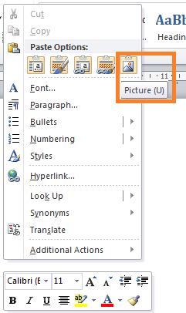
- Example is provided in Figure 3.

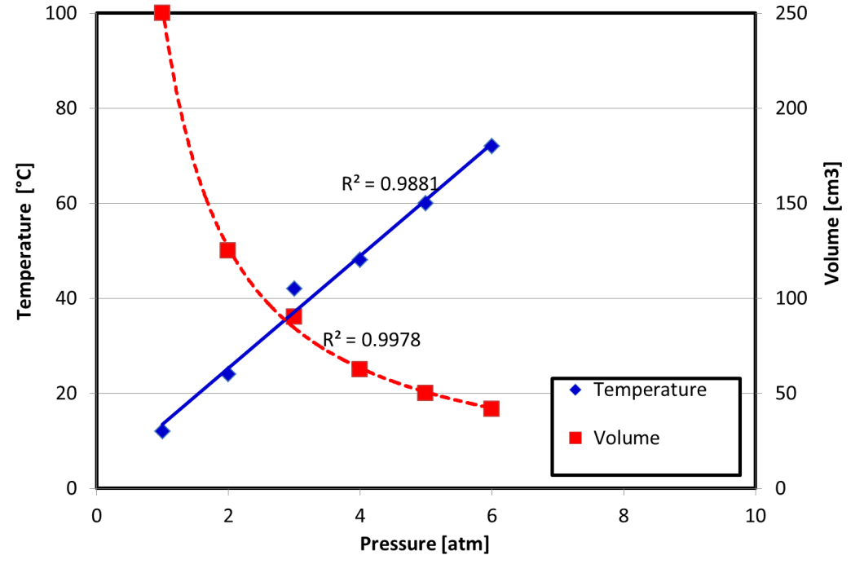
Figure 3. Correlation between pressure, temperature and volume

In addition, please submit us also your excel file when you submit your paper in Online Conference System of ICOMERA 2020. By doing this, the editor can change the format of your paper (not the content) to ensure similar format for all submitted papers.

- Table
General guidance to create a table:
- Table sequence: Calibri, size 11, bold
- Caption of table: Calibri, size 11, flush center, line spacing: single, before: 0 pt, after 6 pt
- Words inside table: (Calibri, size 11, flush center, line spacing: exactly 12 pt, before 0 pt, after 0)
- Rules: Should be 0.5 points wide.
- Use the alphabet sequence, i.e. a, b, c, etc., to add any note in your table (if required) (example in Table 4)
- Example is provided in
  - Table 4: A simple table
  - Table 5: A complex table

Table 4. Guidance to create your table^{a,b}
Function | Information
Table position | Flush center
Words inside table | Flush center  Font: Calibri, size 11  Line spacing: single, before 0 pt, after 0 pt
ª For ICOMERA 2020
^{b} Format for your table

Table 5. A slightly more complex table with a narrow caption.
 | Wake Chi Sqr. (N=15, df=1) | p | Stage 1 Chi Sqr. (N=15, df=1) | p | Stage 2 Chi Sqr. (N=15, df=1) | P
F3 | 1.143 | 0.285 | 0.286 | 0.593 | 0.286 | 0.593
Fz | 1.143 | 0.285 | 0.067 | 0.796 | 0.067 | 0.796
C4 | 2.571 | 0.109 | 0.600 | 0.439 | 1.667 | 0.197

- Equations, mathematics and unit
  - Equation numbering
Make sure that your Equation Editor or MathType fonts, including sizes, are set up to match the text of your document. Equations may be numbered sequentially throughout the text, i.e., 1, 2, 3. An example is provided in Equation 1.
(1)
  - Unit
Apply SI unit with blank space. Hereby exemplary correct and incorrect writing for unit of pressure.
CORRECT:
- Pressure: kg m⁻¹ s⁻²
INCORRECT:
- Pressure: kg/ms²
- Pressure: kgm⁻¹s⁻² (Reason: no blank space between kg and m, between -1 and s)

- Acknowledgement
The author may add acknowledgement in the end of paper before reference list. Please use similar font format.

- Reference list
General rule for all types of reference:
- Please pay careful attention on writing the reference list as many good papers were returned back to the author due to significant error in writing the reference list.
- Font: Calibri, size 11. The words in your reference list may be written in italic or bold, depending on the reference type. Please pay careful attention which reference type should be written in italic or bold.
- Line spacing: Exactly 12 pt, before 0, after 0.
- Flush: Justify
- The reference published before 2012 is maximum 10% of total reference number
- Write the reference number as the sequence of its appearance in the sentence:
Example:
Aurell et al. [4] denoted that a single base propellant consists of Nitro-Cellulose (NC) while the double base propellant consists of both NC and Nitro-Glycerin (NG).
10.1 Reference from journal article
Format
Surname Initial of 1st name, year of journal publication name of journal (ITALIC) Volume of the journal (BOLD) page of the paper

Example
[1] Cavailhès J, Gaign C, Tabuchi T and Thisse J F 2007 Journal of Urban Economics 62 383–404

If there are only 2 authors in your referenced paper, please use word “and” without any coma (,) as provided in the example below:
[2] Ding C and Zhao X 2011 Chinese Economy 44 46–71

10.2 Reference from conference proceeding
Format
Surname Initial of 1st name, year of proceeding publication title of cited paper (the capital letter is only the first letter of the first word) name of proceeding (ITALIC) page number.

Example
[3] Lomakin V O, Reacher J, Doe J 2015 Investigation of two-phase flow in axial-centrifugal impeller by hydrodynamic modelling methods Proceedings of 2015 International Conference on Fluid Power and Mechatronics, FPM 2015 pp 1204–1216

Similar rule applied if there are only 2 authors in your referenced paper (see subchapter 10.1)

10.3 Reference from one single chapter in book
Format:
Surname Initial of 1st name, year of proceeding publication title of cited chapter (ITALIC, the capital letter is only the first letter of the first word) (name of book) name of editor (if any) (City of publication: name of publisher) chapter in book page number

Example:
[4] Kuhn T, Reacher J, Doe J, Cakra A, 1998 Density matrix theory of coherent ultrafast dynamics (Electronic Materials vol 4) ed E Sch¨oll (London: Chapman and Hall) chapter 6 pp 173–214

Similar rule applied if there are only 2 authors in your referenced book (see subchapter 10.1)

10.4 Reference from a book
Format:
Surname Initial of 1st name, year of publication title of cited book (ITALIC, the capital letter is only the first letter of the first word) (City of publication: Name of publisher)

Example:
[5] Whelan C T, Reacher J, Hunt E, 2018 Atomic structure (Bristol: IOP Publishing)

10.5 Reference from bachelor final work, master thesis, and PhD Dissertation
Format:
Surname Initial of 1st name, year of publication title of thesis type of thesis in Italic (either Master thesis or PhD Dissertation) Institution, City, Country
Example:
[6] Roberts P, 2009 Influence of gas burner on EAF energy efficiency Master Thesis University of Manchester, Manchester, UK
[7] Dobson C T J, 2018 Magnetic transport in reaction–diffusion phenomena PhD Dissertation Brunel University, London, UK

10.6 Reference from internet site
You may carefully use the reference from internet site. Only permanent or persistent web links should be used in reference list. Ensure that you cite high trusted internet site and avoid citing from less trusted one, e.g. Wikipedia or blog. This proceeding uses Vancouver style to write citation from internet.

Format:
Since there are many types of internet source that can be used, you may visit the internet link below for more information about Vancouver style.
https://subjects.library.manchester.ac.uk/referencing/referencing-vancouver

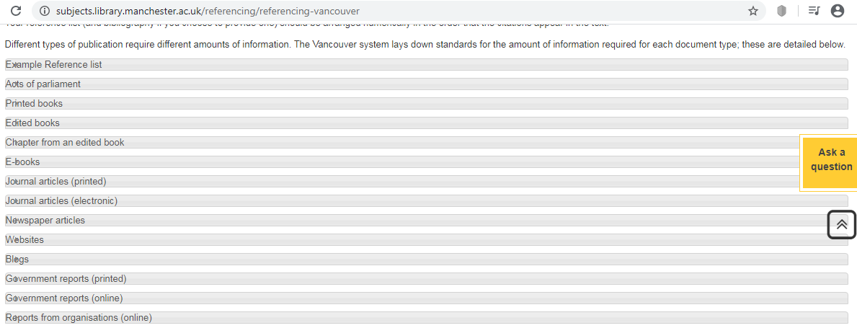

Example:
[8] CNN (2020). US CDC warns against all nonessential travel to China over coronavirus. [online] Available at: https://edition.cnn.com/asia/live-news/coronavirus-outbreak-01-28-20-intl-hnk/index.html [Accessed 28 Jan. 2020].
[9] Universal testing machine. (2020). UE14XX series Computer Control Electronic Universal Testing Machine. [online] Available at: http://www.laryee.com/utm/electronic-utm/24.html [Accessed 28 Jan. 2020].

